DDL AND DML SQL COMMANDS

CREATE TABLE STUDENT (

STUID INT,

STUDNAME VARCHAR(64),

AGE INT,

COURSE VARCHAR(64)

);

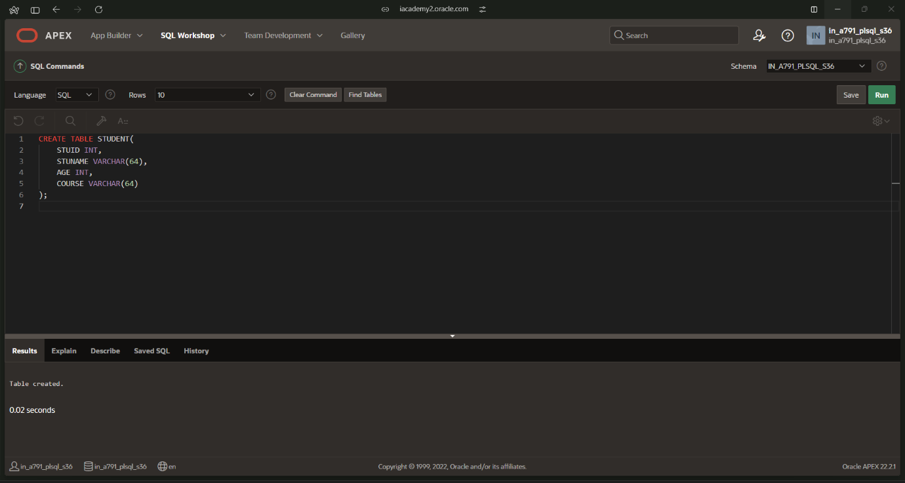

INSERT INTO STUDENT VALUES (1,’NAME’,1,’CSE’);

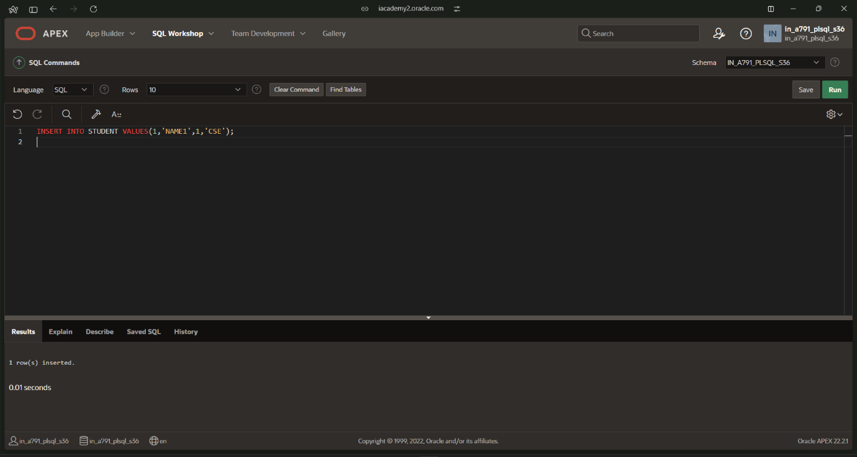

SELECT \*FROM STUDENT;

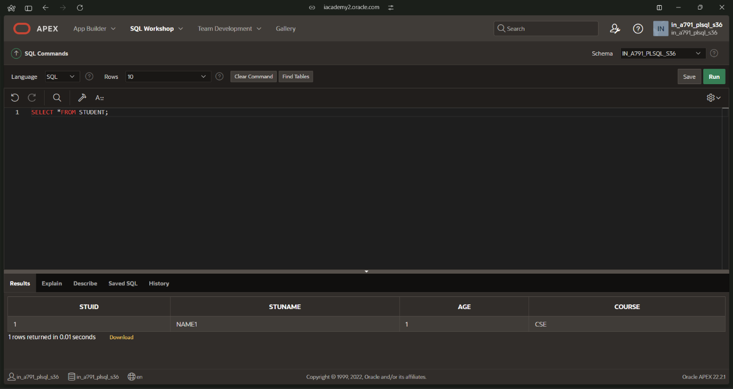

ALTER TABLE STUDENT ADD DEPARTMENT VARCHAR(64);

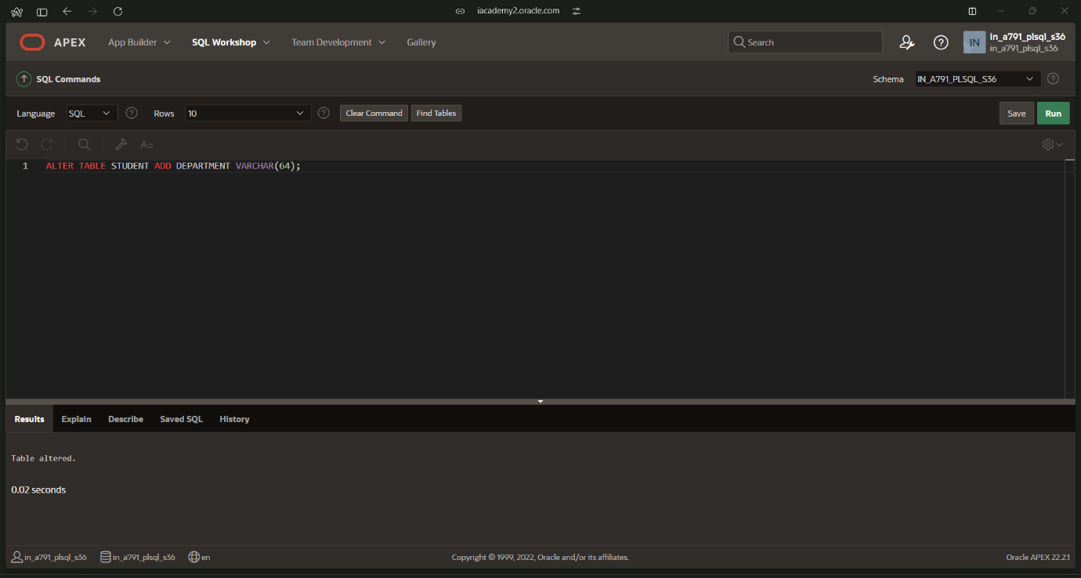

UPDATE STUDENTMARK SET TOTAL=MARK1+MARK2;

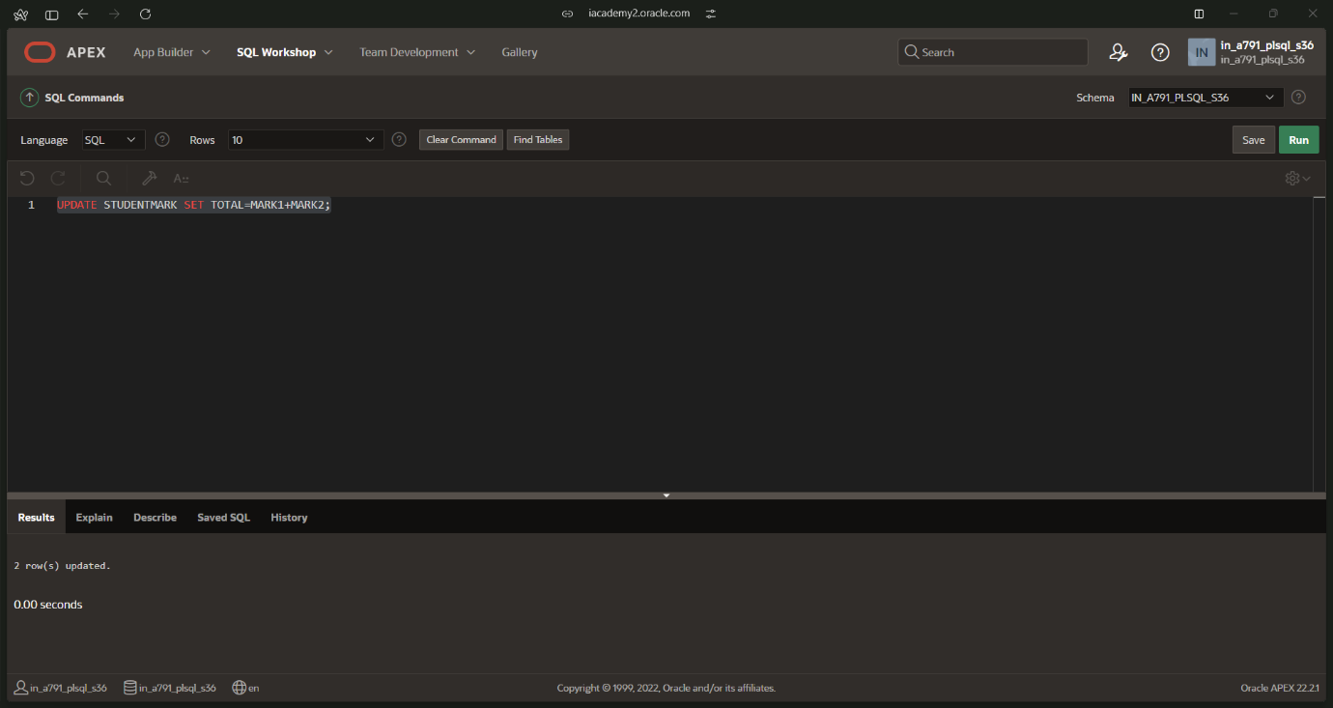

SELECT AVG(MARK1) FROM STUDENTMARK;

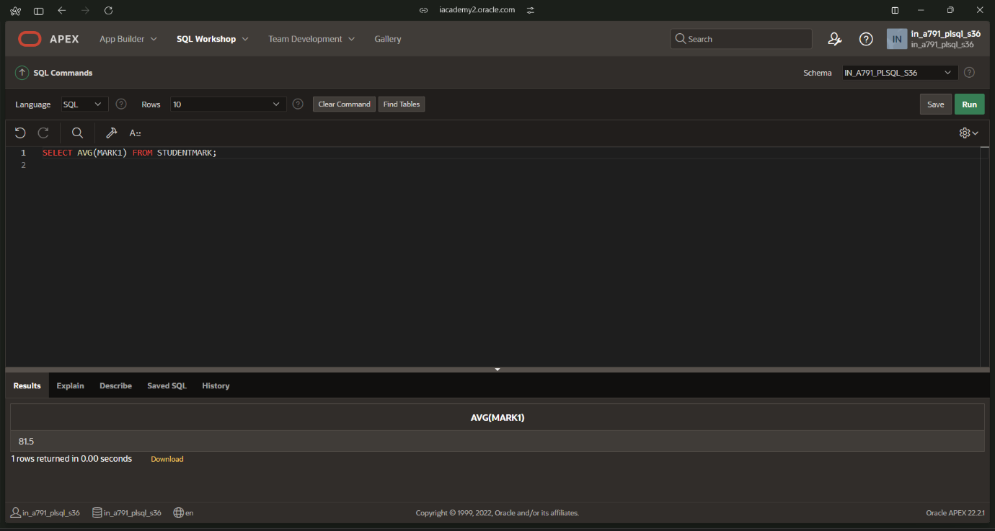

SELECT MIN(MARK1) FROM STUDENTMARK;

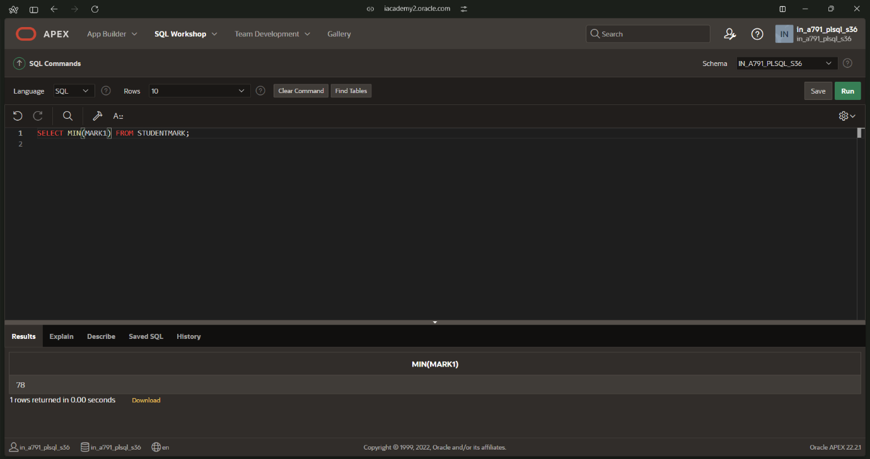

SELECT MAX(MARK1) FROM STUDENTMARK;

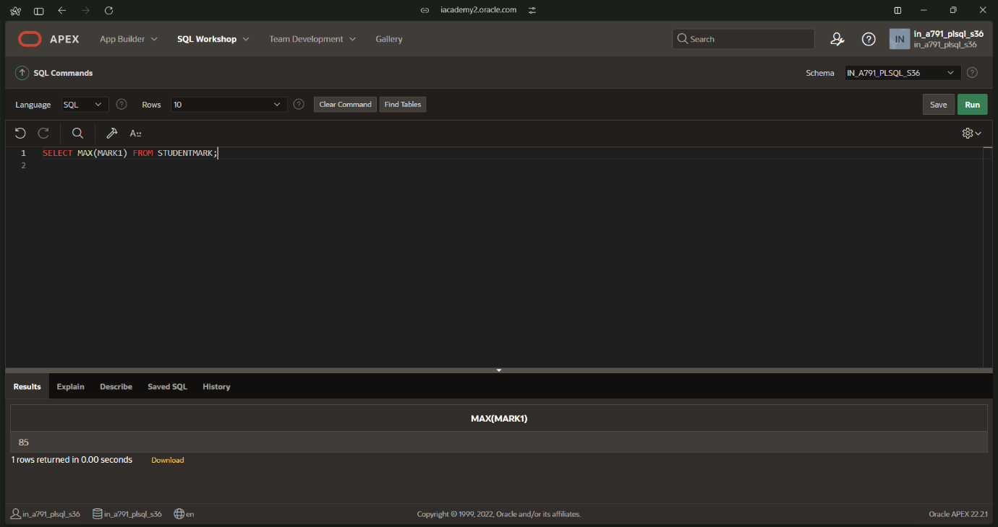

SELECT COUNT(TOTAL) FROM STUDENTMARK;

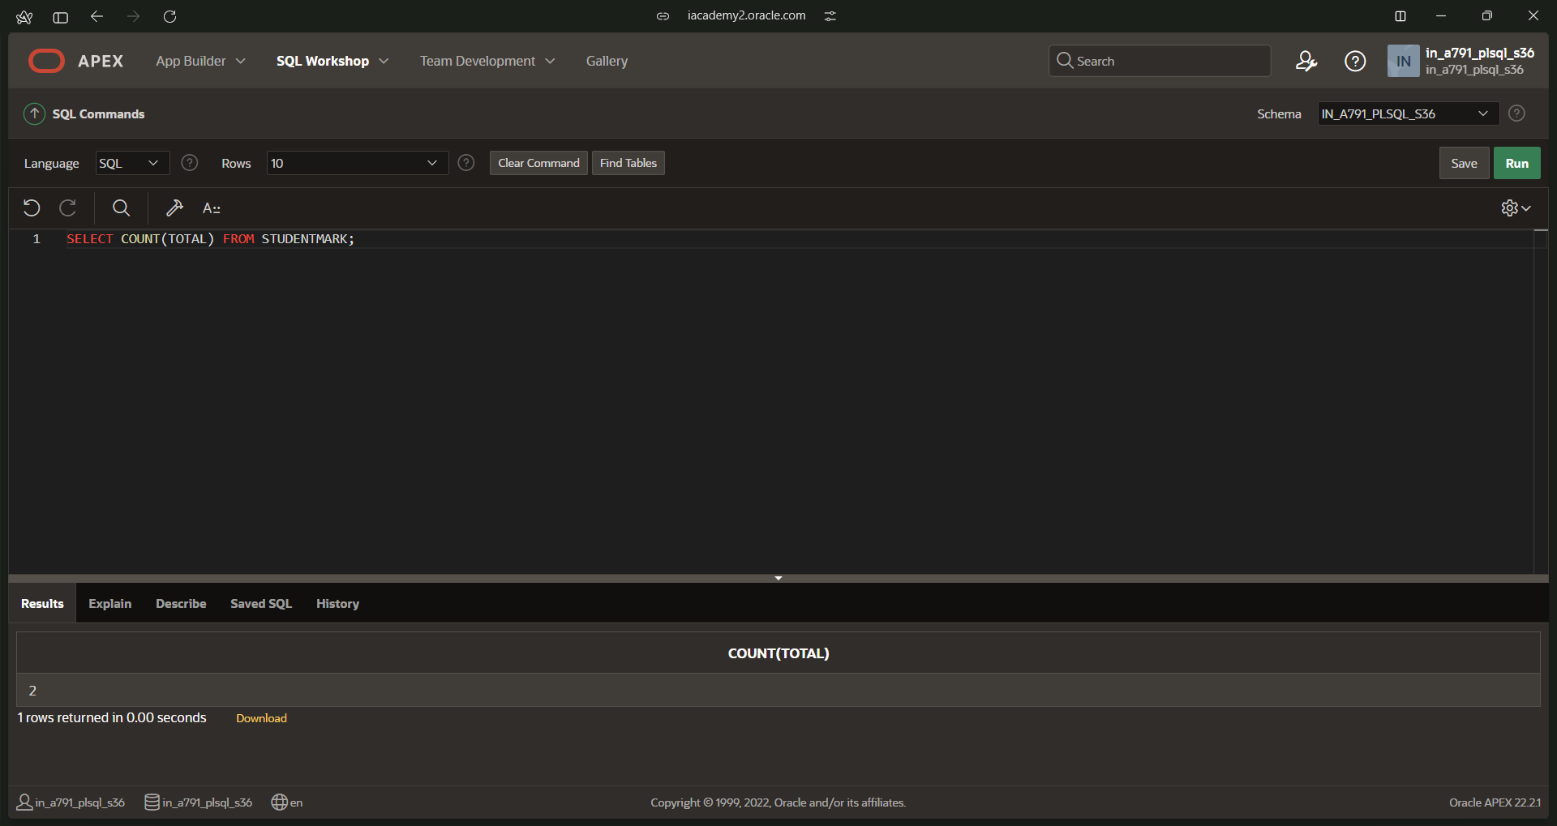

SELECT SUM(MARK1) FROM STUDENTMARK;

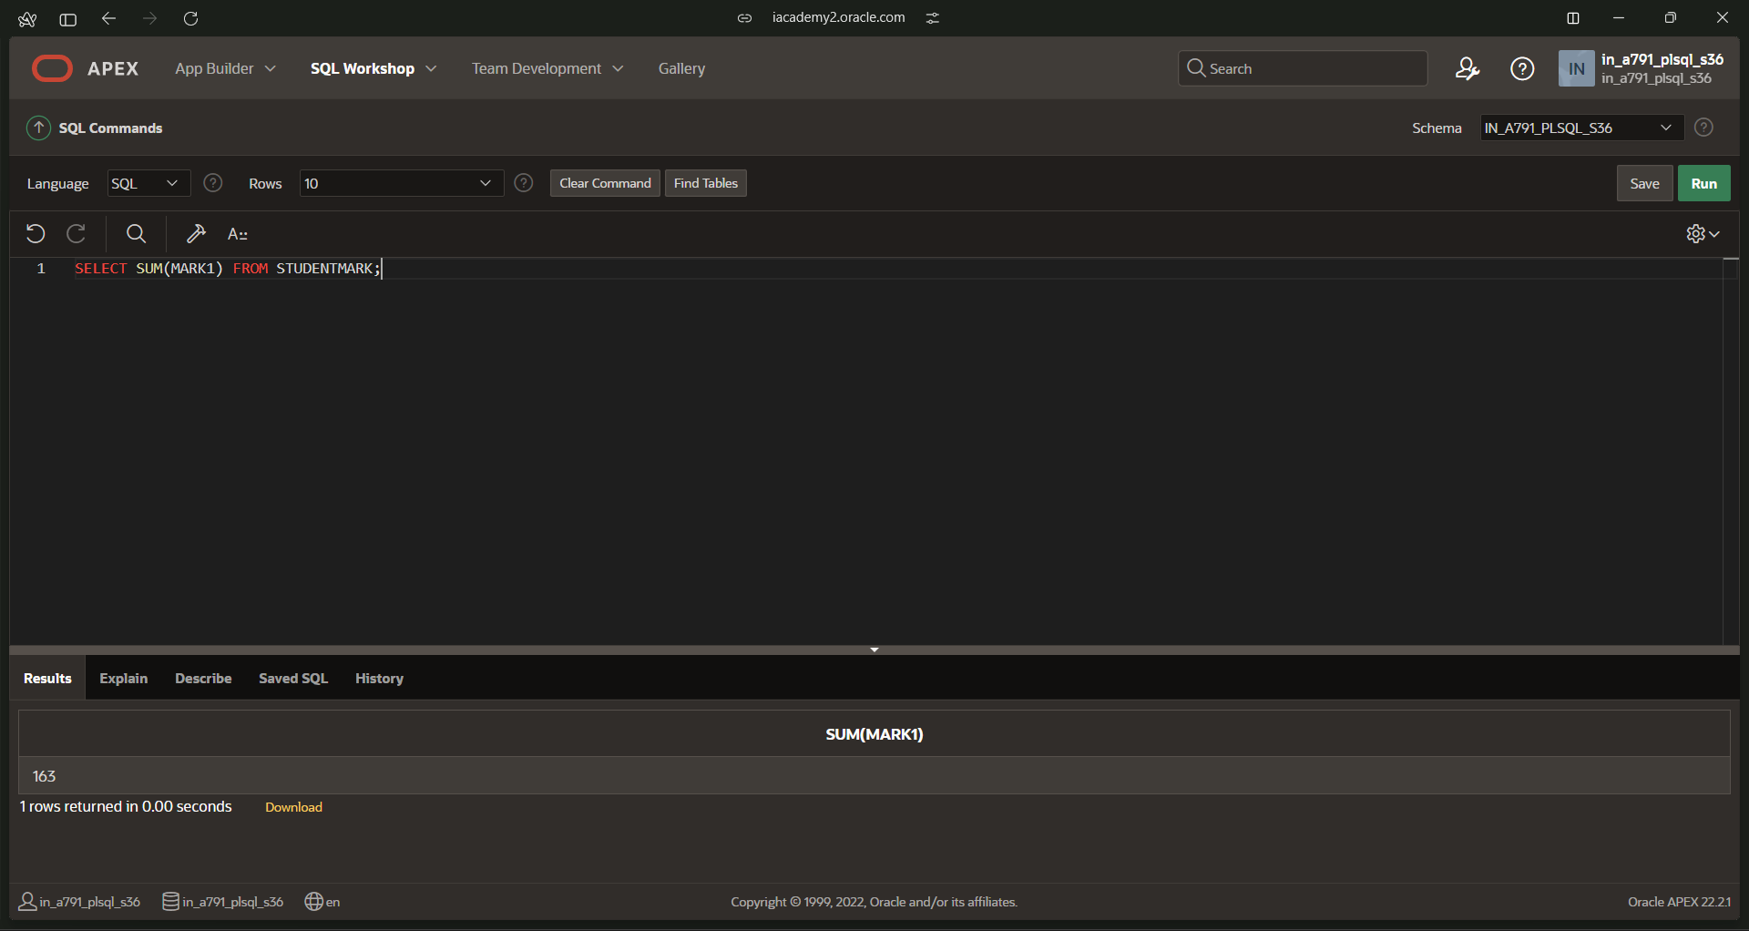

SELECT \*FROM STUDENTMARK ORDER BY STUID;

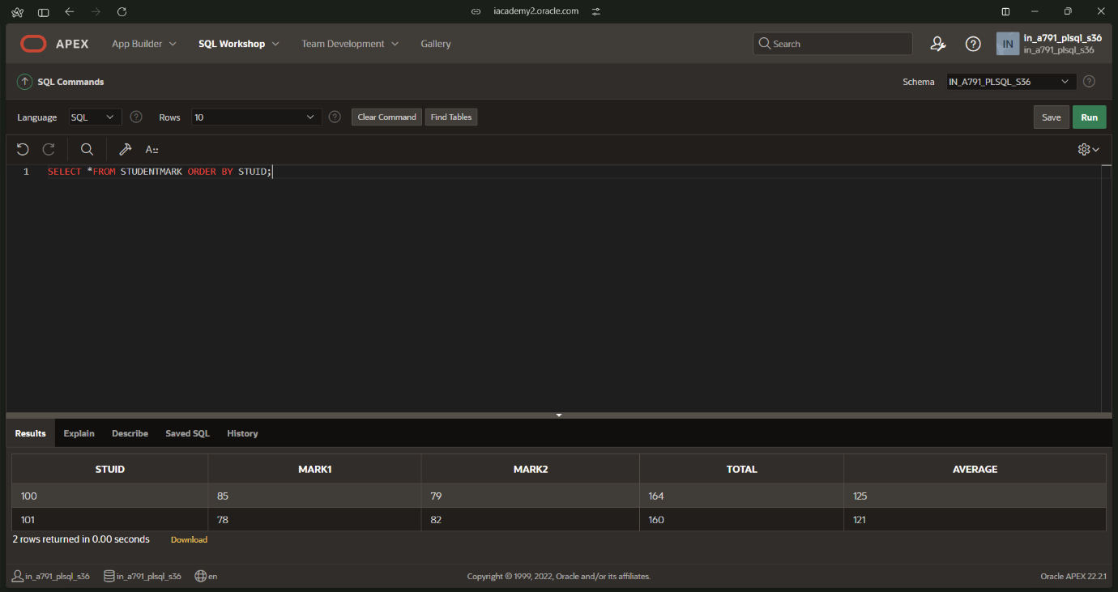

SELECT EMPLOYEE.empid,DEPARTMENT.departmentid FROM EMPLOYEE LEFT JOIN DEPARTMENT ON EMPLOYEE.departmentid=DEPARTMENT.departmentid;